**DAILY ONLINE ACTIVITIES SUMMARY**

|  |  |  |  |  |  |  |  |  |
| --- | --- | --- | --- | --- | --- | --- | --- | --- |
| **Date:** | 20/05/2020 | | | | | **Name:** | D Richard Franklin | |
| **Sem & Sec** | Fourth SEM section A | | | | | **USN:** | 4AL18CS020 | |
| **Online Test Summary** | | | | | | | | |
| **Subject** | | Object Oriented Concepts | | | | | | |
| **Max. Marks** | | 30 | | **Score** | | | 21 | |
| **Certification Course Summary** | | | | | | | | |
| **Course** | Complete Python Bootcamp : Go from zero to hero in Python 3 | | | | | | | |
| **Certificate Provider** | | | Udemy | | **Duration** | | | 2 Hours |
| **Coding Challenges** | | | | | | | | |
| **Problem Statement:** 1. To print duplicate elements of an array  2. To reverse a singly linked list | | | | | | | | |
| **Status:** Completed | | | | | | | | |
| **Uploaded the report in Github** | | | | | YES | | | |
| **If yes Repository name** | | | | | <https://github.com/richard3658/lockdown-coding> | | | |
| **Uploaded the report in slack** | | | | | YES | | | |

**Online Test Details:**

The online test was from module 1 which was about Introduction to the subject and a quick overview of object oriented programming. There were 20+10(programming) questions and the duration was 40 minutes. The questions were optimal and were easy. The score that I received was 21/30.

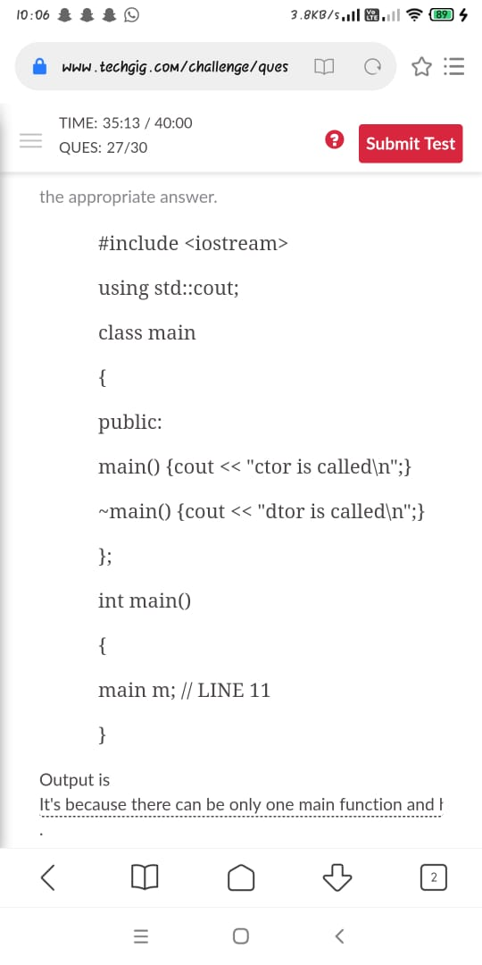

**Certification Course Details:**

**Name of the course**: Complete Python Bootcamp: Go from zero to hero in Python 3

**Certificate Provider**: Udemy

This course has 19 sections and the total duration is 24 hours.

In the third day, I went through the third section of the course and learnt about python comparison operators and the different python statements.

**Snapshot:**

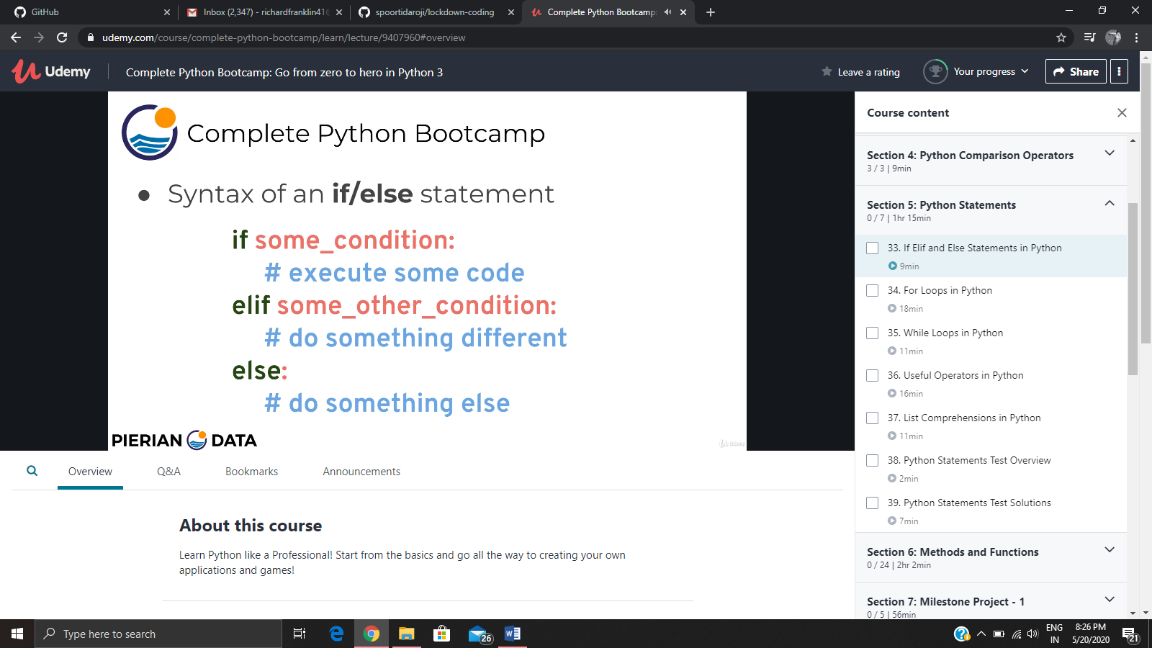

**Online Coding Details:**

Problem 1: (Using JAVA) Given an array a[] of size n which contains elements from 0 to n-1, write a program printDuplicates which prints the duplicate elements of the given array. If no duplicate element is found print -1.

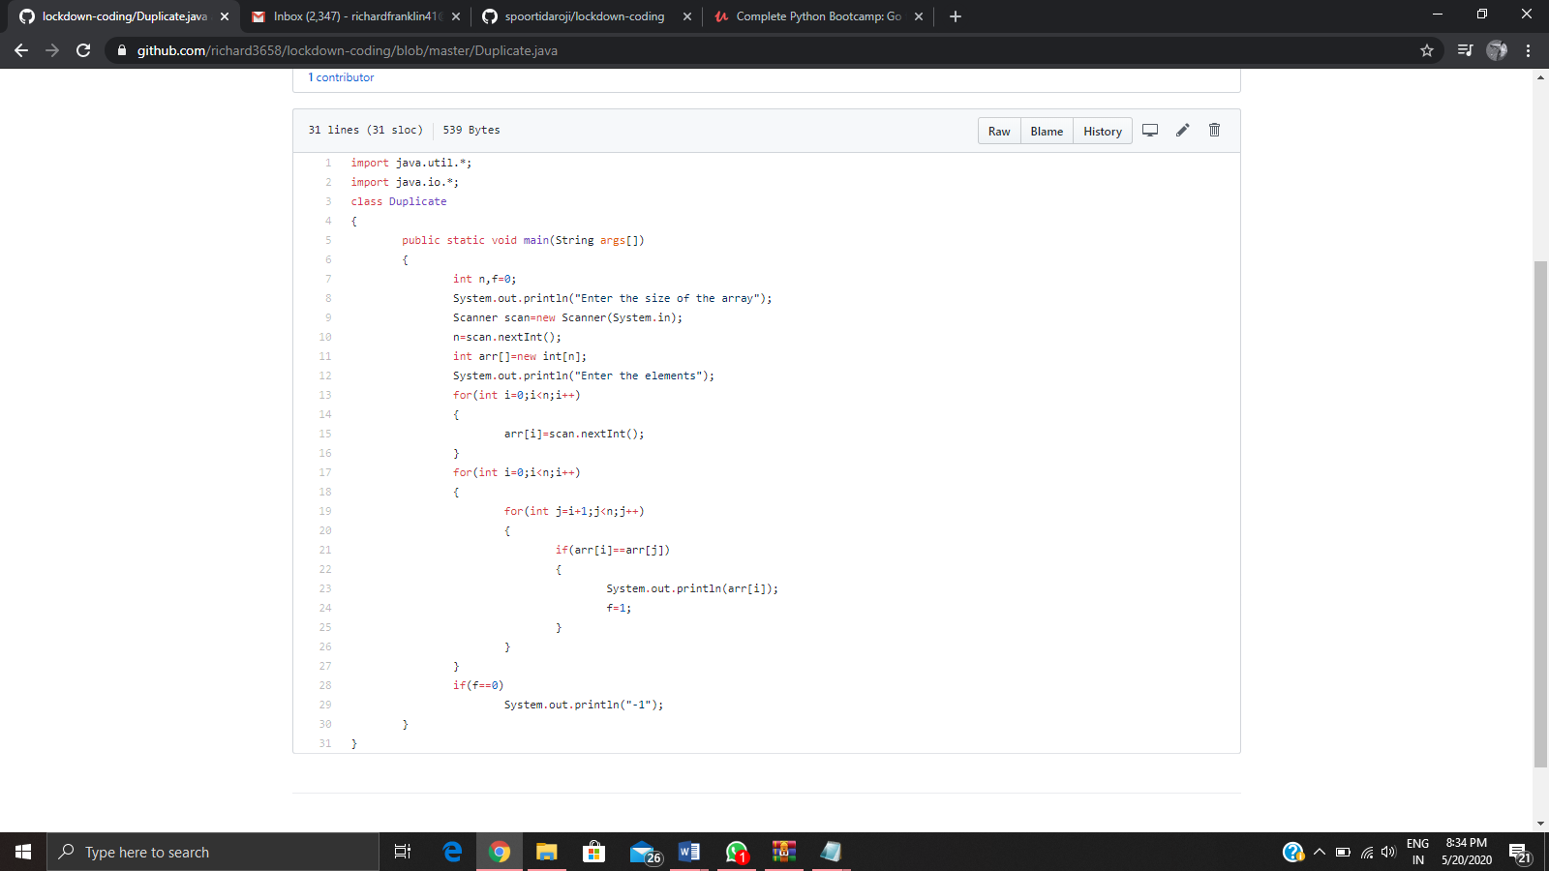

Problem 2: (using C language) [Write a C Program to Reverse a Linked List (SLL) in groups of given size.](https://github.com/orgs/alvas-education-foundation/teams/2nd-year/discussions/67)

